Workflow of the Digital Actor Hologram Performance based on Digital Synthesis

Fu Linwei, Jiang Haitao, Ji Yun,Young Jick Jang,Tae Soo Yun

Department of Visual Contents
Graduate School, Dongseo University
Busan, South Korea
flw0819@gmail.com, yntaesoo@gmail.com

Abstract

As the basis for the exploration of the production process about digital actor hologram performance, this paper proposes a fundamental workflow to quickly and efficiently complete the project which rebuild the case of 2016 Kim Kwang Suk’s Hologram Concert Hall by combining with CG technology and digital computer imaging technology. With the rapid development of digital technology, the digital actor hologram performance has attracted a wide attention as the most popular technology at present. It has become a new topic faced by technical workers that how to use the existing digital technology to quickly and efficiently complete the project. Using the method proposed in this paper can save more time and reduce the production funding in a simple way.

Keywords：Hologram; Digital actor; CG; Digital image

I. Introduction

In recent years, the application of the hologram projection technology in the public life has made more and more people experience the fun of virtual interaction, and the hologram projection will enter the rapid development period. While the application of hologram projection technology in stage performance can best reflect its features of the technology novelty, the strong three-dimensional sense, combination of virtuality and reality and strong interactive experience, so it will inevitably attract the attention of many audience. In some of the large stage performances, the hologram projection technology is used at the right time reasonably to reproduce the classic and revive the past e stars on the stage through the digital role in the way of hologram projection, the three - dimensional imaging technology combined with virtuality and reality can make people feel novel and enjoyment. This form of stage performance combines the modern technology and traditional stage performances, thus to create the high commercial value. At present, more and more stage designers around the world are using digital character technology to create and complete their art works. The combination of digital character technology and stage performing arts has brought a comprehensive innovation to the stage performance, and we are in a new era of using technology to create art. The virtual characters constructed by the three-dimensional animation production technology, optical illusion technology, high-definition video projection technology and interactive technology, have broken through the time and space constraints on the traditional stage design, and provide a new form of art show for the stage performance. It has become a new topic for technicians of how to use the existing technology to complete the production of digital characters for stage performances quickly and efficiently. This article has conducted the subject exploration mainly through the following forms. Part 1 is the simple analysis on the project of Kim Kwang Suk Concert. Part 2 proposes the overall process of CGI techniques according to the production. Part 3 analyzes the detailed production process. Part 4 carries out a contrastive analysis between the project and the projection test result. Through the four aspects above, this paper puts forward a complete process reference for the hologram performance using CGI techniques for the production of digital characters, and conducts the actual production. A relative project is obtained to speed up the efficient production process.

II. <2016 Kim Kwang Suk’s Hologram Concert Hall> project analysis

2016 Kim Kwang Suk's Hologram Concert Hall was developed by Daegu Digital Industry Promotion Institute (DIP), which had used the modern CG technology to "revive" the past South Korea famous singer Kim Kwang Suk, and carried out singing on the actual stage (Fig. 1). It’s a new type of cultural realization combining the traditional cultural industry and modern cutting-edge information and communication technology (ICT), as well as the first project in the whole South Korea using the hologram projection to restore the passing characters.

Fig. 1 Kim Kwang Suk’s Hologram Video Data

Kim Kwang Suk’s Hologram performance is through the analysis of Kim Kwang Suk’s real concert image information, the body was shot in the studio through the avatar actor to make the real appearance of the expression and mouth-shaped muscle with the computer graphics (CG) and reference to the character information. The whole process of Kim Kwang Suk’ performance was produced through the green screen shooting and post-technical synthesis. A real stage scene was built in the actual concert hall, thus to present the performance in front of the audience through the hologram projection [1].

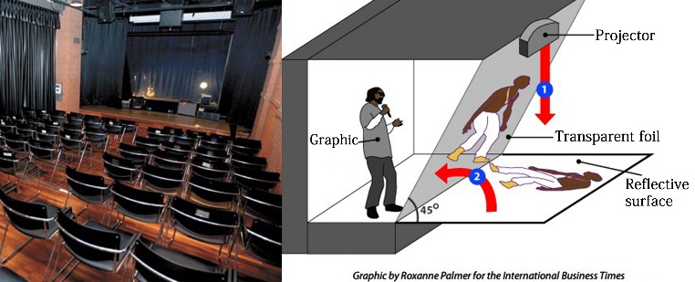

Fig. 2 Stage Scene & Imaging Principle

Fig.2 shows the realistic stage and the principle. After editing the video data on the computer, the editor uses the projector to play the film on the hologram projection membrane on the stage, and this hologram projection membrane has the half translucent and half reflective feature, and as being translucent, it can show the surrounding stage environment while maintaining a clear image at the same time, thus to produce realistic three-dimensional space effect with the help of specific lights [1].

III. Digital actor hologram system overview

In order to achieve the hologram projection of digital characters more quickly and efficiently, and on the basis of referring to the project production, the method with the combination of CG technology and digital image technology has been proposed in this paper, short as the "CGI" technology.
CG is an abbreviation for computer graphics, and it’s a general term for all the graphics drawn by computer software. With the formation of a series of industries relating to the visual design and production using the computer as the main tool, the fields using computer technology for visual design and the production are generally called CG internationally. It includes both technology and art, and almost contains all the visual arts creative activities of today's computer era, such as graphic print design, web design, three-dimensional animation, film and television special effects, multimedia technology, computer-aided design based architectural design and industrial design [2].
Digital Image Processing is a method and technique using computers for removing noise, enhancing, recovering, dividing and feature extracting. Generally, there’re three main purpose of image processing (or processing, analyzing): (1) to improve the visual quality of the image, such as adjusting the brightness of the image, color transformation, enhancement, inhibition of certain components as well as the geometric transformation of the image which improve the visual quality of the image. (2) to extract certain features or special information contained in the image, which can often facilitate the computer analysis of the image. The process of extracting a feature or information is a pattern recognition or computer vision preprocessing. The extracted features can include many aspects, such as frequency domain features, grayscale or color features, border features, area features, texture features, shape features, topological features and relational structures. (3) for the image data conversion, coding and compression to facilitate the image storage and transmission. No matter what purpose of processing the image has, they all require the image processing system composed of a computer and an image special equipment to import, process and export the image data [3].

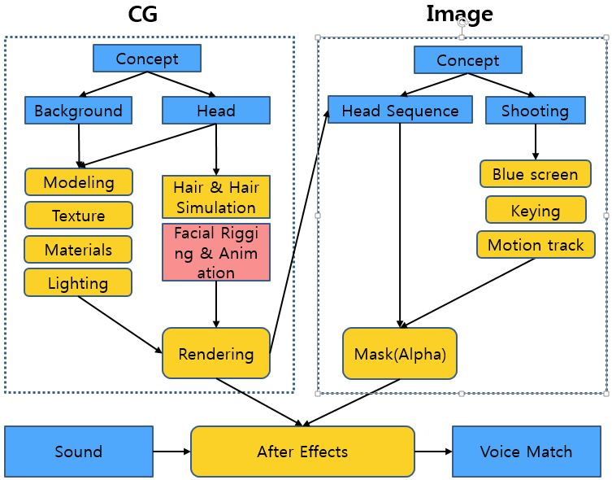

Fig. 3 Progress preview

As shown in Fig.3, the concept design was done according to the reference project of 2016 Kim Kwang Suk`s Hologram Concert Hall in the beginning, and the whole production is divided into two different templates of CG and Image. The CG part includes the construction of the stage background and the production of digital character head model, and the Image part consists of two parts of the head sequence which are frame processing and body image source shooting. The image data matching each other is export as the source after the completion of the production of different modules, and combined in the image processing software (After Effect). The image is export as the hologram projection source after the sound matches.

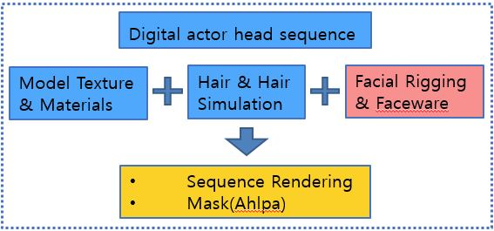

Fig. 4 Digital actor head sequence progress

The production of CG is mainly making the model in three-dimensional graphics software (3D Max, Autodesk Maya) on the computer, in order to restore the actual stage effects, the model is made on the basis of the relevant information collection. After the foundation model is created, the model source is processed and given high-quality texture, simulate the lighting environment of the stage, and finally render the output. The production of the head model is also carried out according to the same process, compared to the background modeling, the production of character models need to add the Hair simulation and bone binding. Complete the Facial Rigging (Fig. 4). Directly in the modeling process can be more convenient for facial animation production by using the Faceware technology. In dealing with the image part, it can produce directly in the synthesis software, all of the sources are match into the overall adjustment, which can greatly increase the efficiency of technicians.

IV. Digital actor hologram performance production

Before the project was started, a simple conceptual design was carried out with reference to the actual project of the second part. In order to facilitate the detailed division of labor and to graps the progress of the overall process, storyboard are designed according to the actual situation of the CG part of the content and the actual shooting content (Fig. 5).

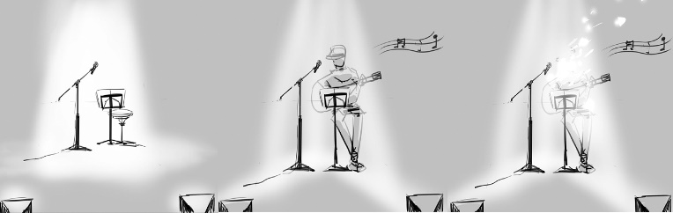

Fig. 5 Digital actor hologram performance concept

Which in the background stage by adding a microphone, speakers, music stand, background curtain and other stage equipment, the actual shooting only the actors themselves and playing with the guitar. And the screen size, lens movement, lighting environment, lighting and recording time for a simple set for the entire project to lay the foundation for the production.

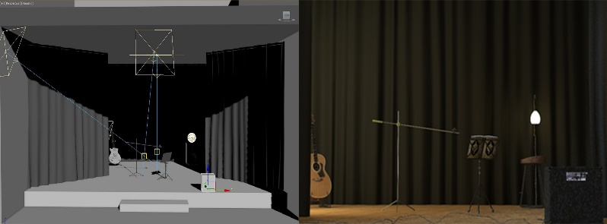

Fig. 6 Modeling & Texture & Rendering

The stage scene in CG part will be made into a three-dimensional model to better match the digital role for the stage environment needs, the digital imaging technology is a graphics processing technology based on 2D, the three-dimensional stage scene has broke the limits of digital imaging in the space, and provide the flexible adjustment opportunities for the post production, including lighting, cameras and a series of detail adjustment. Moreover, the stage properties are made into the three-dimensional model, which is more convenient to construct the sense of distance and the depth of view in the space which able to create a harmonious and three-dimensional stage space conveniently (Fig. 6).

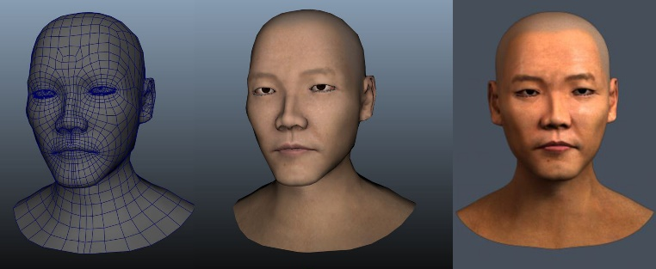

Fig. 7 Modeling & Texture & Rendering

Digital character head production is divided into two parts of CG and Image, which is also a reflection of CGI techniques in this paper. As the digital character is the existence of the virtual role’s people, the Digital Image Processing cannot provide the corresponding facial animation. In order to simulate the performance effect more vividly, the three-dimensional head model is created through CG, we have proposed a new method using 3D scan to diretly create a head model, it can save a lot of time in this way [4], and the Faceware technology is used for the face capture of the real actors, the obtained data is bound to the well-made head model to get a complete facial animation (Fig. 7). In the way of sequence output via rendering the facial animation on the head from the three-dimensional model to 2D image data, to provide convenience for the later Digital Image Processing editing.

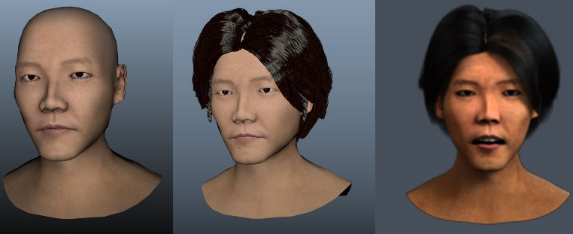

Fig. 8 Modeling & Hair Simulation & Rendering

The output head model sequence frame is used as the source of the digital character synthesis, and restore the role image of the project to a certain extent. In order to achieve a more realistic effect, the hair system is also added and the light matching is conducted (Fig. 8). During the rendering and exporting, two channels of RGB and Alpha are set to retain, and this source facilitates the separate data processing of the head in the post-production to shortens the work process and increases the quality of synthesis.

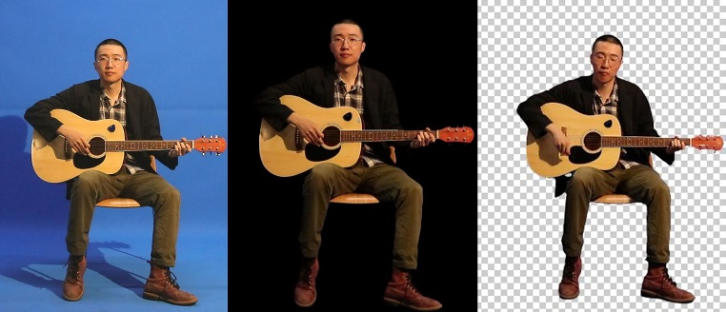

Fig. 9 Shooting & Keying & Alpha

The Digital Image Processing is used for the production of the digital role’s body part, and the actor's physical action is recorded by the blue screen shooting for the video source (Fig. 9). In the process of shooting, the corresponding lighting setting is conducted to match the lighting environment when the head model is output, a spot light is added at the top of the actor from top to bottom to highlight the shadow of the chin part, thus to reduce the difficulty of the post-production sources composition and to save the production time. During the blue screen shooting, the floodlight is added on the blue background to clearly distinguish between the background and performance objects, to provide convenience for the post-production editing and ensure the image keying quality. The video is shot in the way of the tripod fixed camera angle, which can greatly reduce the lens shaking, enhance the stability of the screen effect, and save time for the follow-up motion track to a certain extent. In order to achieve a more realistic effect, the actor has the action of singing synchronized with the background music and is dressed in the similar clothes in the recording.

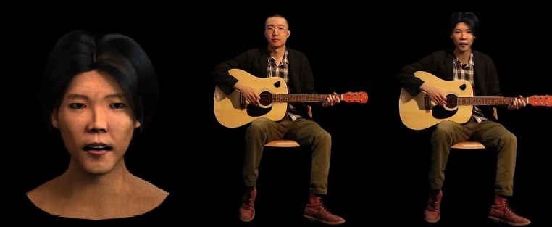

Fig. 10 Head Sequence & Body Source & Compositing

The composition of digital characters is divided into two parts, Part 1 is the composition of head and body sources, and Part 2 is the composition of body source and background stage. Where, the composition in Part 2 includes the light, shadows, the overall proportion of the screen and deal with other element. Both compositon of these two parts is carried out in After Effect, and belongs to the digital imaging part in the CGI mode. The production of Part 1 is to track the body movement trajectory through Motion Tracking, binds the motion trajectory to the head animation source frame with the alpha channel information, and matches the motions of two different sources (Fig. 10). As the souce is produced independently, there are some differences in the color and lighting information, the overall color of the screen is corrected with the added mask and color correction tool to export the compose information according to the corresponding size, thus the entire composed screen becomes more harmonious when the quality of the picture is ensured.

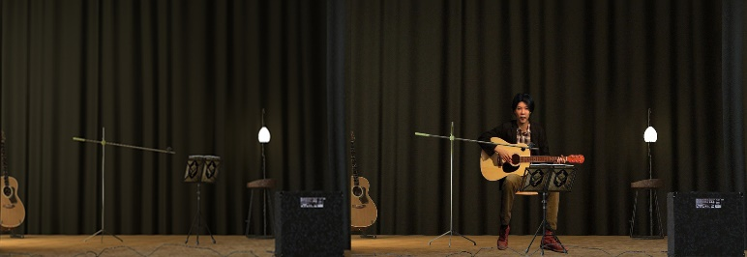

Fig. 11 Background & Final Video
In order to simulate the real spatial relationship, each source in the stage is treated separately in the stage compositon of Part 2. Although all the sources have taken into account of the lighting factors in the early production process and have done the corresponding light treatment, differences in brightness and perspectives still exist when they’re composed into a complete picture (Fig. 11). Therefore, the light and color corrections are made for each individual element in composing the final picture. Moreover, the mode of improving the overall brightness of the digital character and weakening the brightness of the surrounding environment, can make the audience's visual center more focused on the performance part of the digital character in the middle. A small amount of noise and smoke effect have been added to the final output of the screen in order to highlight the stage effect.

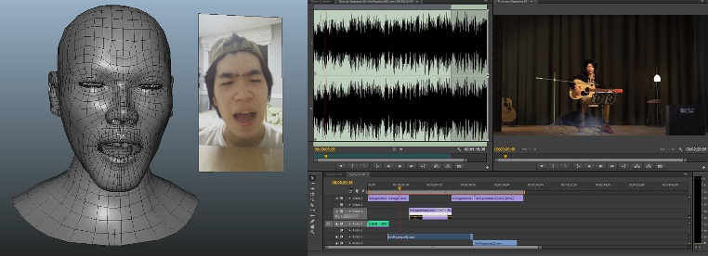

Fig. 12 Faceware Animation & Voice Match

The final dubbing of the digital character is performed after the completion of the overall picture production. The process of sound processing is also divided into two parts: the early stage and late stage. The early stage includes the Faceware Animation and the actual shooting recording, and the late stage includes the track correction and screen matching. The Faceware technology can instantly capture the character’s facial expressions through the video capture device, and import the expression into Autodesk Maya's MotionBuilder. After a quick one-key calibration, Faceware can track and solve the expression, and map it directly to the 3D model [5]. In such a way, the real character’s singing can be reflected to the head model in real-time, and the production of facial animation and sound matching can be completed at the same time. The body source also goes through the background music matching in the shooting process, and the actor performs the solo part of the guitar part according to the background music. In the end, two recorded tracks are separated in Adobe Premiere and then to match the output screen source with the sound compose technique (Fig. 12).

V. Digital actor hologram test

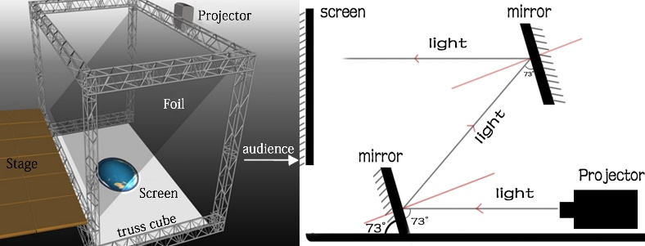

Fig. 13 Hologram projection concept

In the traditional large-scale stage art design, the hologram projection generally uses the 45 ° hologram projection film. Set up an LED screen on the stage floor, project the pre-made video through the projector above the screen onto the LED to display, the visible light can be refracted to the eyes of the audience through 45 ° holographic projection film, as the stage is higher than the audience, they cannot see the screen on the ground, thus a magical and three-dimensional effect will appear on this stage (Fig. 13).

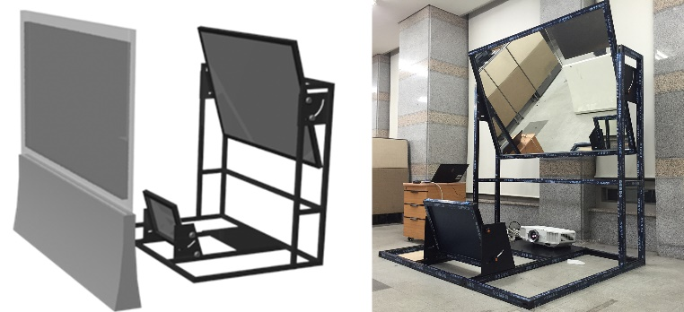

Fig. 14 Hologram projection equipment

The test conditions are very restrained in this paper, according to this principle, 45 °angle between the holographic film and the ground is changed by adjusting the angle reflected by the two mirrors, thus the picture is directly projected to the screen perpendicular to the ground and shows in front of the audience more intuitively (Fig.14). This will not only save the space use of the entire equipment, but avoid the high production costs of the LED display and hologram film, so as to achieve the purpose of finishing the hologram projection of the digital character quickly and efficiently [6].

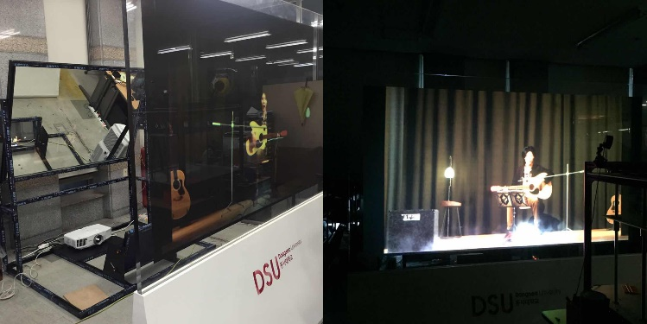

Fig. 15 Hologram projection

As shown in Figure 15, there are still some shortcomings till now:
1. Due to the age of the character in the production project, the CG model lacks of clear reference source, the desired picture quality is not achieved in the model production, and there’s a huge difference between the character modelling and the original character.
2. All the source production is separate and independent, and lack of the systematic coordination and distribution, so a lot of problems occur in the later composition process, such as the matching between the head movement and the body, the matching between the facial mouth animation and background music, the matching between the body action and background music, as well as the coordination between the scene lighting and character lighting.
3. Technical limitations in the post dynamic capture, which can only identify the object movement in the two-dimensional level and cannot track the role’s movement trajectory in the three-dimensional space, and restrained the role’s rich body movement in the performance (such as the head swinging and body shaking), and in the sub-mirror production, the picture movement is also minimized, making the whole output screen look very blunt, and the effect is not ideal.

Conclusion

Hologram projection technology still belongs to the forefront of science and requires us to make continuous exploration, and the hologram projection performance of digital characters will become more diversified in the practical application in the future, making people feel the wonderful experience from different areas. Based on the analysis of the hologram projection performance project of digital characters, this paper has completed the exploration of the set of production process combined with the principle of the hologram stage imaging. Through the methods of combining the CG technology and computer imaging technology, it has made a detailed records of the complete series of production process from the concept design from the beginning to the final production, and added a series of new production methods including the three-dimensional stage background, Faceware and sound synthesis on the basis of the original production of 2016 Kim Kwang Suk's Hologram Concert Hall, thus to complete the project production more quickly and efficiently.
With reference to the production template proposed in this paper, the quality of the source will be completely enhanced in the next production, which will combine the head and body sources, throw off the production mode of Digital image processing, create 3D digital role model in the full CG mode, use motion capture animation to replace the actual live shooting, and achieve the full three-dimensional hologram projection effect through the real-time rendering function of the game engine.

References

[1] Kim Kwang Suk’s project analysis:
https://www.youtube.com/watch?v=AtrfF8D3bZk
- Sung-Kyu Choi, “A Study on Technology Trends of CG in Visual Effects and Suggestion”. Journal of Koera Multimedia Society 12(4), 04, 591-599, 2009.
- Chul Young Choi, Seungwoo Cho, Junesok David Lee, “Study of CG Character Animating Pipeline for Human IK and Kinect”. The Korean Journal of Animation 9(4), 12, 180-199, 2013.
- Jiang Hai Tao, Ji Yun, Tae Soo Yun, “The Digital Actor Hologram Performance Project: Achieving the Photorealistic Facial Skin and Rendering”. International Conference on Culture Technology, 01, 2017.
- Kim, Hae-Yoon, Park, Dong-Joo, Lee, Tae-Gu, “Comparative Analysis of Markerless Facial Recognition Technology for 3D Character`s Facial Expression Animation -Focusing on the method of Faceware and Faceshift-”. Korean Society of Cartoon and Animation Studies, 221-245, 2014.
- Fu Lin Wei, Jiang Hai Tao, Ji Yun, Jick Jang, Tae Soo Yun, “The Digital Actor Hologram Performance Project: Hologram Based Digital Actor Performance Using Real Time Game Engine ". Journal of Korea Multimedia, 05, 2017.

